Fife Mountaineering Club Newsletter February 2023

The year has started more or less as indicated on the Day Meets programme but with some gaps due to unappealing weather forecasts and some variations in the destinations! The New Year outing was, at the last minute, shifted from Barry Buddon to a walk to Tensmuir Point from Tayport due to a variety of reasons which included a wish for a slightly later start from me due to icy conditions in Perth with extensive windscreen scraping required combined with another member not being free to join the group unless the start was delayed. By the time we could all assemble we realised that if we headed to Monifieth and then walked out to Barry Buddon our return walk would be in darkness. A group of seven of us consisting of 4 members plus relatives of three of the members enjoyed a crisp cold but bright sunny day walking out to Tentsmuir Point, turning South along the beach where lunch was enjoyed watching seals on the sandbanks. The return included a route that took us briefly through part of the forest.
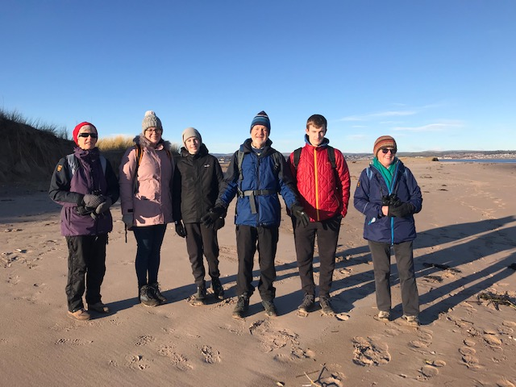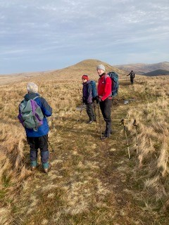
The other outing that has taken place consisted of five members who on the day when Drumochter was on the programme decided to go to the Ochils which had been planned but not taken place two weeks earlier. They had an enjoyable day in good weather when they completed a different circuit from the Glen Sherup car park from the outing from there a year ago with their highest point being Skythorn Hill which is just over 600metres. It is looking as though those who were thinking of heading out tomorrow (19th Feb), which is down on the Meet list as to Glenshee, have been deterred by a deteriorating forecast and I heard on the radio this morning that the snowgates on the road at the Spittal were closed today! I can see from my window as I write this that there has been new overnight snow on the hills there!
The AGM was held on 20th January on Zoom which meant that once again Vivien was able to join us from Devon and Zoom cetainly suits those of us, including myself, who do not enjoy the significant drive to and from St Andrews on a January evening. The business side of the meeting was straightforward with the committee remaining unchanged and there also being no change in the subscription levels. This remains as £25 for full membership of which currently£17.55 is the current annual sum that goes to Mountaineering Scotland(MS) to cover the Club’s affiliation fee to this organisation which includes liability insurance for any Club related activity. Those who are members of more than one Club and whose £17.55 is being paid to MS by their other Club need only pay £7 for their FMC membership and for those just wanting to keep in touch and whose membership is purely social the membership fee is £5. Your subscriptions are now due so please, if you wish to remain a member, could you pay Irene, our treasurer, either by cheque made out to “Fife Mountaineering Club” or by doing a bank transfer into the Club account of the appropriate sum but please name it so that Irene knows who it is from. Let me know if you require the bank details. The business meeting was then followed by the usual quiz which was prepared by last year’s winner who were the combination of Les and Irene. It was then presented by Morag who due to having a Zoom account was hosting the meeting. Irene had handed me a memory stick which contained the quiz at Tentsmuir on 2nd January but I then had to trust my grandson, Adrian, who can be seen in the Tentsmuir beach photo, to take it home and give it to his Mum without losing it! He achieved this, the Quiz was enjoyed by all and the winner was Catherine.
The year ahead is looking more normal in what is planned due to being free of Covid restrictions. We have been notified that after a gap of 3 years due to Covid the Mountain Mind Quiz will take place this year at the Queens Hotel, Dundee on Wednesday 15th March at 7.00 for 7.30 pm. I hope we manage to have a team present representing us.
We have been offered the use, for a weekend, of the usual cottage in the Boat of Garten area that we have visited almost every year for about 50 years, except for missing out the last 3 years because of Covid. The weekend offered is Friday to Sunday 21st – 23rd April. It is actually a very comfortable house in a lovely area with plenty of space for any member wishing to come. We were originally offered and spent a weekend there back in about 1970 due to the owner who lived in St Andrews being a friend of the then Club Secretary! Neither of them are still alive but I communicate with the next generation of the family, who do not live in St Andrews! Can you let me know if you would like to come on that weekend.
When I wrote the December Newsletter I was already giving thought to and searching for members opinions as to where the club might go for its 2023 Summer week. The result of the suggestions received is that Reiff Beach Cottage, which is at the end of the road NW of Achiltibuie, has been booked for the week 17th – 24th June. It will take a maximum of 8 and 7 of us have booked their places by paying a deposit. It is a 4 bedroom house with a maximum of 8 allowed to stay so one more could be fitted in. It is well placed for hills in the Assynt area.
Hopefully the coming Spring will have some good weather over the weekends which will tempt members out and that there will be some Sundays when the hills climbed will actually match what has been planned and circulated on the Day Walks Programme!
Jean

